Ngarra Murray, Rueben Berg elected as new First Peoples’ Assembly of Victoria co-chairs
Dechlan Brennan - July 26, 2023

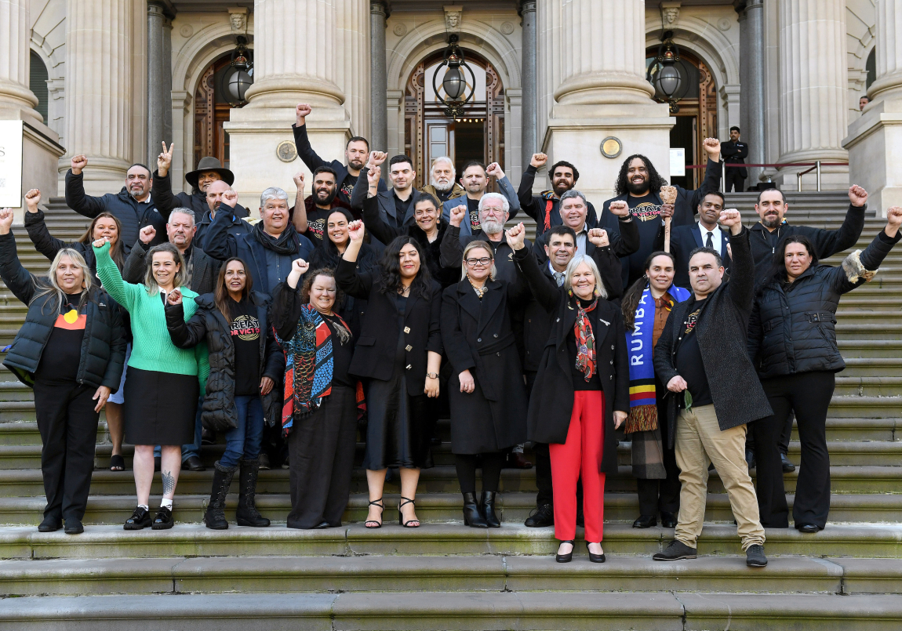
Members of the First Peoples’ Assembly of Victoria at the opening meeting of the
First Peoples' Assembly of Victoria's second term.
(Image: Morgan Hancock/AAP)

The First Peoples' Assembly of Victoria has elected two new co-chairs at the first sitting of the Assembly's second term today.
Wamba Wamba, Yorta Yorta, Dhudhuroa and Dja Dja Wurrung woman Ngarra Murray and Gunditjmara man Rueben Berg were both elected to oversee the Treaty negotiations with the Victorian state government.
They replace the outgoing co-chairs, Proud Nira illim bulluk man of the Taungurung Nation Marcus Stewart and proud Bangerang and Wiradjuri woman Aunty Geraldine Atkinson, who both gave their farewell addresses at Victorian Parliament today.
Ms Murray, who was re-elected to the assembly for the Metro region, is a community development and human rights expert. For the past decade she has led Oxfam Australia's First People's programme.
Ms Murray thanked all the First Nations people who had be involved in the journey to Treaty, including by enrolling and voting in the recent Treaty elections.
"History shows that real change comes from the people," she said.
"Whether we're realising our rights, fighting racism, or standing up for our Country, it is everyday people who are the original drivers of change - people like us.
"We must make sure that Treaty respects our rights, dignity, and sovereignty as First Peoples, and leads to a healed and healthy country for all of us."
In her member statement after being elected, Ms Murray stated that: "Any treaty negotiations must be grounded in customary lore, human rights, and our inherent rights as First Peoples."
Mr Berg, who trained as an architect, is returning to the Assembly, and is a reserved seat holder, representing the Eastern Maar Aboriginal Corporation.
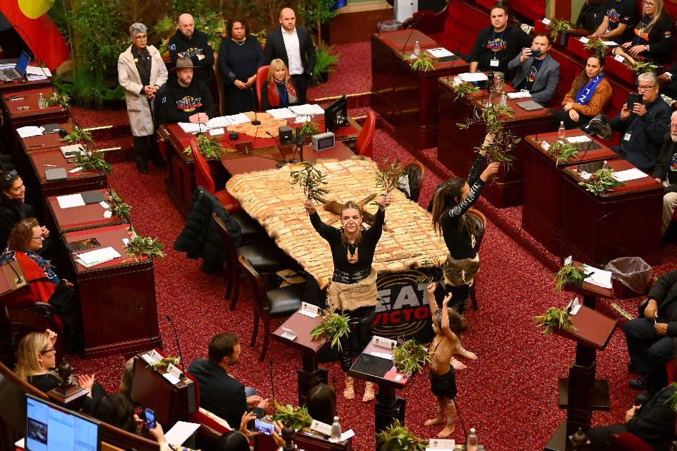
The opening meeting of the First Peoples' Assembly of Victoria's second term included a
performance from Djirri Djirri dancers.
(Image: Morgan Hancock/AAP).

He was previously the Commissioner for the Victorian Environment Water Holder and a member of the Heritage Council of Victoria.
In his member statement, Mr Berg said that the Assembly needed to "keep yarning about the details that Community would like to see."
"Do we want dedicated seats in the Victorian Parliament that Aboriginal people vote for, do we want our own Parliament for our people? Maybe we want both. Nothing is off the table, so let's go for it!"
Mr Berg said he viewed Treaty as the journey, rather than the destination.
"The journey to Treaty will empower us as First Peoples to make decisions about our lives, our communities, our lands and our waters," he said.
"This is a turning point for our people, our state and our nation. Treaty will lead to a better future for our mob, one where we can go from surviving to thriving.
"And it will lead to a better future for all Victorians, where our remarkable cultures and languages are embraced, celebrated and embedded into everyday life."
Both co-chairs thanked the Assembly for entrusting them with the responsibility.
This week sees the Assembly holding its first meeting of the new term. It will continue at Parliament house on Thursday.

