New community fishing ponds to reel in more anglers in Merrigum

GOULBURN VALLEY WATER / ABOUT US / NEWS CENTRE / NEWS AND MEDIA RELEASES / NEW COMMUNITY FISHING PONDS TO REEL IN MORE ANGLERS IN MERRIGUM

12 October 2023

A unique, Victorian-first project to transform unused water storages into community fishing lakes is now officially open.

Dunyak Moira (meaning fishing lake in Yorta Yorta language) is a partnership between Goulburn Valley Water and the Burnanga Indigenous Fishing Club, where two unused lagoons have been reimagined into a community-accessible fishing site.

The two lagoons – one a 50 megalitre and the other a 12.5 megalitre – had sat empty and unused for more than 20 years at the Merrigum Water Treatment Plant after the water supply was reconfigured via a pipeline from Kyabram.

Works to transform the site, including rehabilitating the water storages, bringing in native fish and constructing fishing pontoons have been ongoing since mid-2021, with the lakes filled in April 2022.

Dunyak Moira was opened on Wednesday, 11 October by Goulburn Valley Water Board Chair Mark Stone AM.

Opening hours will be from dawn to dusk on Fridays, Saturdays, Sundays, and school holidays, as part of an initial trial schedule.

Mr Stone said he hoped Dunyak Moira would leave a lasting legacy for the community.

“Dunyak Moira is testament to what can be achieved through a shared vision, collaboration and a passion to create beneficial outcomes,” he said.

“We hope this becomes a really beneficial space for Merrigum and helps to draw more tourists to the region, as well as being somewhere new for people to enjoy the outdoors and connect to nature.

“Creating access to recreational spaces at is also something we’re committed to doing, because we know how important this is to increase liveability in our communities and the flow on benefits spaces like these have for helping to improve health and wellbeing.”
Burnanga Indigenous Fishing Club President Corey Walker said the opportunities offered by Dunyak Moira would continue to create positive impacts for many local groups and communities.

“This will be great for the Merrigum community and for the broader local fishing community as well to have a new fishing spot,” he said.

“These lakes will also help us encourage more people to get out fishing, including young people, and will create opportunities for us to pass down knowledge to younger generations.

“Through our club we want to provide activities on Caring for Country and Culture through fishing; and to encourage more people to get outdoors to help improve mental health and wellbeing and Dunyak Moira will help us to achieve that goal.”
Goulburn Valley Water Managing Director Steve Capewell said he was thrilled by the support for Dunyak Moira already shown by the community and local businesses and organisations.

“We’ve had a number of local businesses come on board to support the development of the project, whether it be donating materials, time or expertise, to help us bring Dunyak Moira to life, and what we’ve created is better than we could ever have imagined at the beginning of the project,” Dr Capewell said.

Almost 100 large native fish – including Murray cod and Golden Perch – have been relocated into the lakes in partnership with the Victorian Fisheries Authority as part of dewatering programs across northern Victoria, with hopes for seasonal fingerlings from the Murray cod. The lakes will be catch-and-release only, to help protect native fish.

The project has involved partnerships from a number of local businesses and organisations to help develop the site, including:

- Duck nesting boxes installed on both lakes in partnership with Field and Game
- Donated concrete pipes and rootballs from storm damaged trees installed on as ‘fish hotels’ to create an artificial habitat on the lake floor
- Water storage rehabilitation and complete revegetation of the site, including aquatic plants for animal refuges
- Fishing platforms upcycled from a large water barge used on another GVW project
- A new bridge across the channel to connect the two lakes
- Solar pumps to recirculate and aerate water
- Access ramps on the Burnanga Moira (Cod lake) for people to launch kayaks or canoes

People can find out more about Dunyak Moira, including opening times, at gvwater.vic.gov.au/dunyak-moira

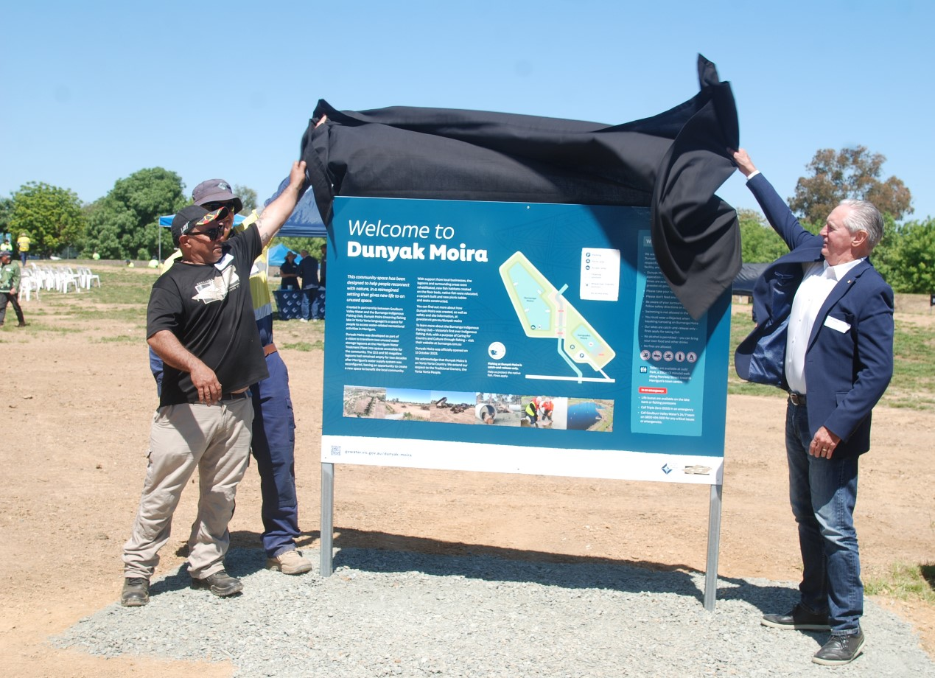
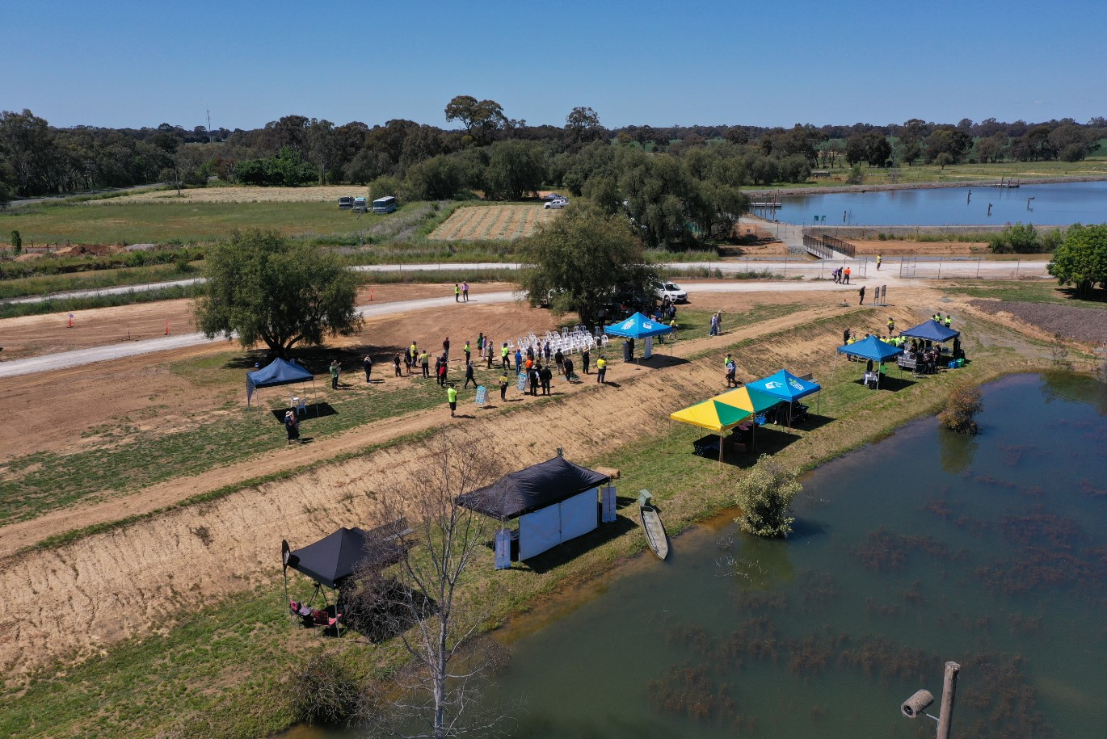
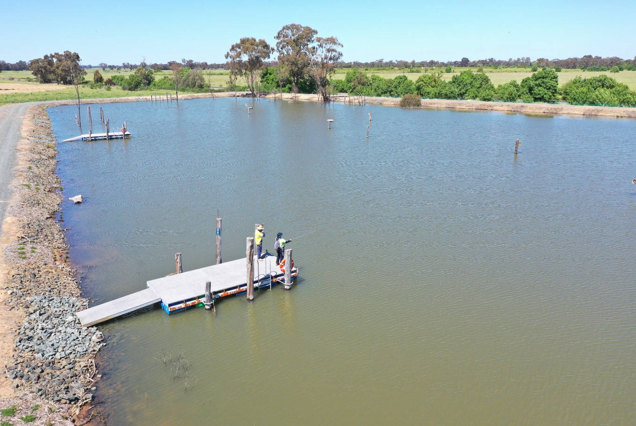

Goulburn Valley Water acknowledges the Traditional Owners of the land on which

