Devastating truths must be told and heard in the quest for a new nationhood
ByPaul Briggs
MARCH 30, 2022
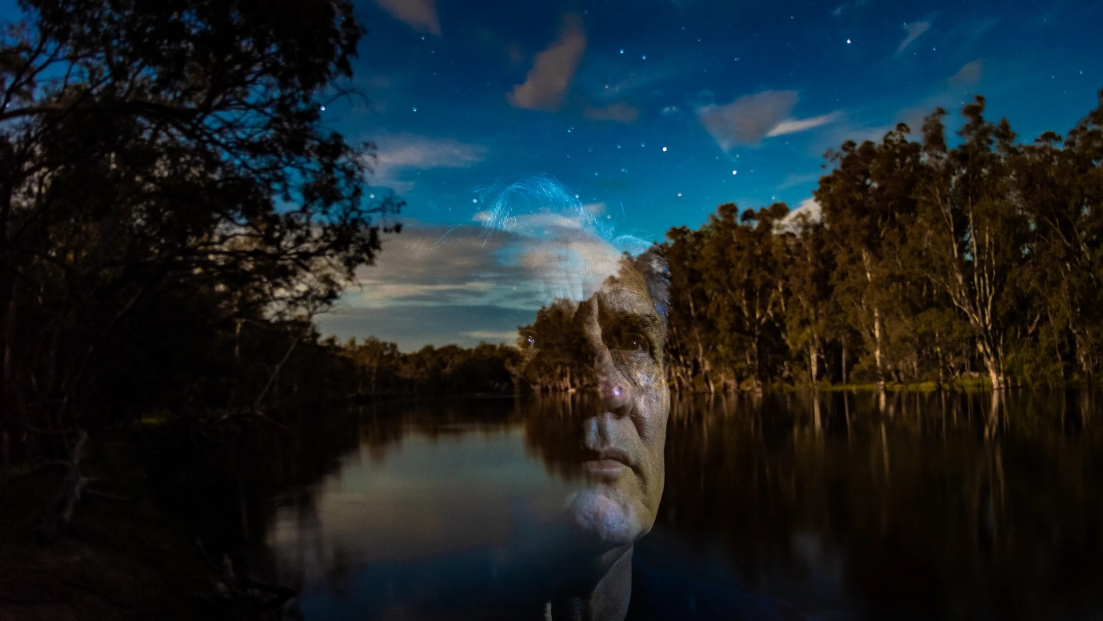
Yorta Yorta, Wurundjeri, Wemba Wemba and Wongaibon man Paul Briggs on
his Country on the Dungala (Murray) river.
CREDIT:JUSTIN MCMANUS

The denial of invasion is a denial of truth. The leaders who sailed into Botany Bay denied our humanity. The nation was built on conquest. Invasion gave licence for atrocities and genocide in the cause of dispossession. Our sovereignty was not acknowledged then or since.
These truths need to be told and heard if we are to construct a shared and mutually respectful national identity. A just and inclusive society cannot be built on the foundational lie of terra nullius. Nor can it ignore the historical role of the monarch and the Christian church.
Denial of truth will eat away at the soul of the Australian people and prevent any chance of shared pride in our nationhood. The nation cannot be reconciled without First Nations people being at the core of the Australian identity.
My fervent hope is that truth-telling can build a platform for growth, so we can reposition the rights of First Nations people in the minds of everyday Australians.
My grave concern is that we may not yet be mature enough as a nation to grasp this opportunity and address these truths. We have not yet educated and informed Australians in every walk of life: in our workplaces, our pubs, our schools, our sporting arenas. And not nearly widely enough in our leaders.
Truth-telling must necessarily begin with invasion in 1788. The nation was built upon acts of violence. Our sovereignty was never ceded. Our humanity was denied. We were treated as sub-human.
These devastating truths must be told and heard; not to point fingers or apportion blame, but rather to create room and opportunity for a shared understanding and a new nationhood.
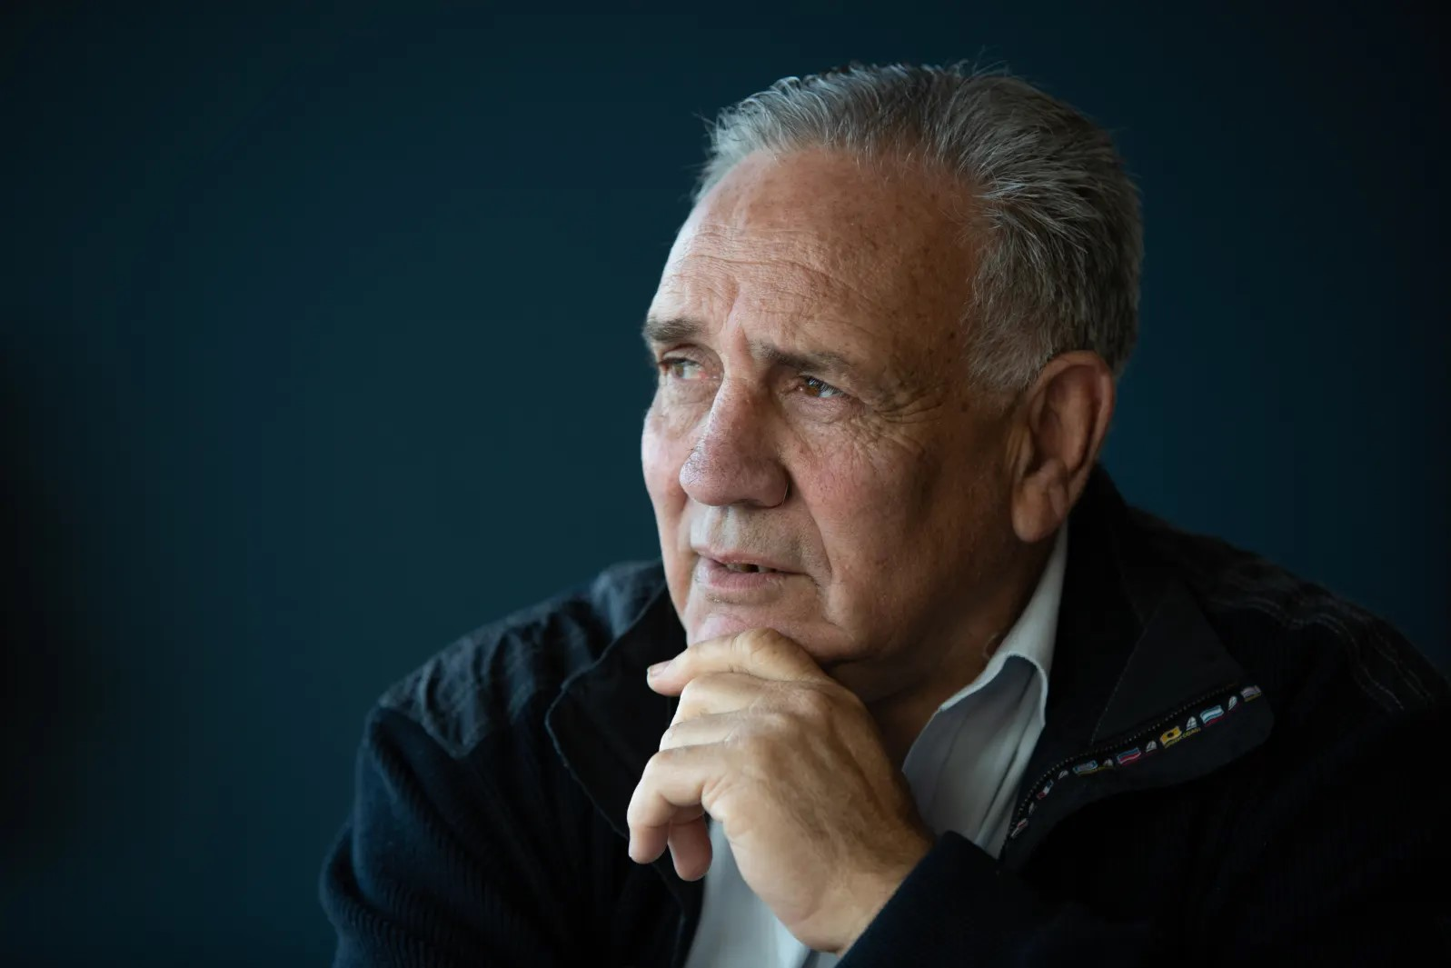
Paul Briggs: “Denial of truth will eat away at the soul of the Australian people.”
CREDIT:AUSTRALIAN FINANCIAL REVIEW.
In the search for a national identity, Australia turned first to the monarch and the Christian church. It could have turned to its First Nations, the oldest living culture on the planet, but chose not to do so then or since.
In my region, Dungala Kaiela (also known as the Goulburn Murray), we thought our native title rights had been recognised by the Mabo decision of 1992. Instead, the courts chose to apply a burden of proof – continuous observance of traditional laws and customs – that ignored our vibrant and continuing living culture. It exonerated and rewarded land theft, while making us “invisible” in our own lands.
Whose truth can invalidate our rights and our culture?
From being secure in our culture and land base, we were exiled to the Maloga and Cummeragunja missions in the late 1800s. Since the early 1900s, we have felt the pain and ongoing intergenerational trauma of the Stolen Generations. In 1939, we walked off Cummeragunja to protest at the conditions and control over our lives.
Throughout our history of dispossession and marginalisation, we have proudly sustained the strength and resilience we call “Nanyak”: the invincible spirit of Yorta Yorta and First Nations peoples in our region.
Our “Nanyak” continues to be challenged by the ongoing impact of racism on our confidence and sense of identity. Racism cuts deep: it perpetuates trauma and curtails aspiration.
The ABC reported last year that the Greater Shepparton Secondary College was described in an independent report as “a picture of systemic racism and cultural exclusion”.
In our schools? Whose truth is this to own?
Recently Josephine Sukkar, chair of the Australian Sports Commission, delivered the Dungala Kaiela Oration. In calling for a national approach to racism in sport, she proposed “a shared cultural vision for all Australians”, adding: “We can no longer leave the job of advocating for their own human rights to the ones whose human rights have been compromised. That is not right and that is not who we are. We are better than this.”
First Nations organisations in Dungala Kaiela continue to seek constructive engagement and common purpose. We call this “Repositioning Value”: harnessing the cultural, social and economic value we bring to regional prosperity.
Our region recently launched the Goulburn Murray Regional Prosperity Plan, a shared vision to generate mutual prosperity by restoring a thriving First Nations economy. Achieving economic parity by 2036 will add $150 million each year to regional productivity.
The plan recognises the rights of First Nations people to contribute and benefit from the regional economy, while acknowledging the historical journey for the region. It challenges the “invisibility” of First Nations people: Where we have previously been held back by the historical legacies of dispossession and colonisation, we are building a shared sense of purpose and a newfound optimism.
It will take great courage and leadership to speak and hear the truth. How we adopt that truth will shine a light on who we are, the values we hold dear, and our character and standing as a nation.

