Australian Paralympic community mourns the death of trailblazing wheelchair basketballer Kevin Coombs
Posted Fri 6 Oct 2023 at 8:45amFriday 6 Oct 2023 at 8:45am

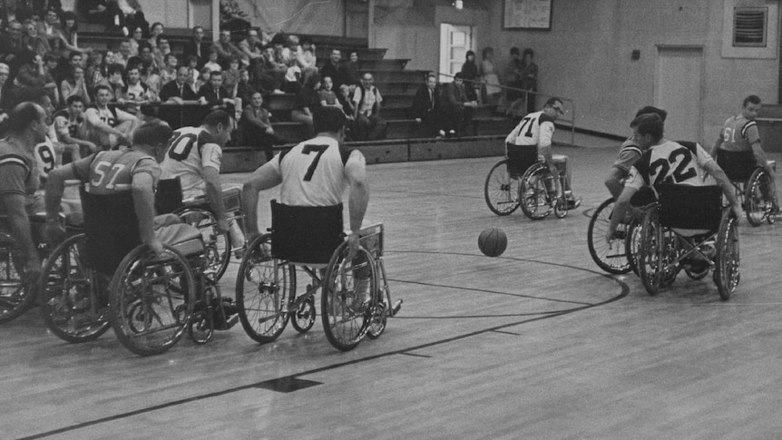

Wheelchair basketball was one of the first events included in the Paralympics, with Kevin Coombs one of Australia's first competitors. (Getty Images)
Travelling to the first Paralympics was an achievement in itself for Australian sporting pioneer Kevin Coombs.
Warning: Aboriginal and Torres Strait Islander readers are warned that the following story contains an image of a deceased person.
- Kevin Coombs attended the first Paralympics in Rome in 1960 as a wheelchair basketballer
- Coombs would compete at four more Paralympics and carried the torch at Sydney 2000
- The Paralympic community also lost six-time gold medallist Tracey Freeman this week
Decades later, one of the Paralympic movement's most revered figures would reflect that his medical support staff — let alone the athletes — weren't sure how it would work.
Not only did Coombs compete at the inaugural Rome Games in 1960, the wheelchair basketballer would go to another four.
The first Indigenous Australian to compete at a Paralympics or Olympics died on Thursday, aged 82.
It follows the death of fellow Australian Paralympic Hall of Fame member Tracey Freeman this week.
"Kevin and Tracey were inducted into the Australian Paralympic Hall of Fame at the same ceremony in 2016, and to lose two legends within days of each other makes this a very difficult time for the Australian Paralympic movement," Paralympics Australia president Alison Creagh said.
"Kevin was a trailblazer who embodied the true spirit of the Paralympic movement.
"His contributions, both on and off the court, have had a profound impact on Australian para-sport and he will forever be remembered as an inspiration to Australian athletes, not just those with a disability.
"As the first female athlete from Australia to win a Paralympic gold medal in athletics, Tracey blazed a trail for future icons of our movement, like Louise Sauvage and Madison de Rozario, to follow."
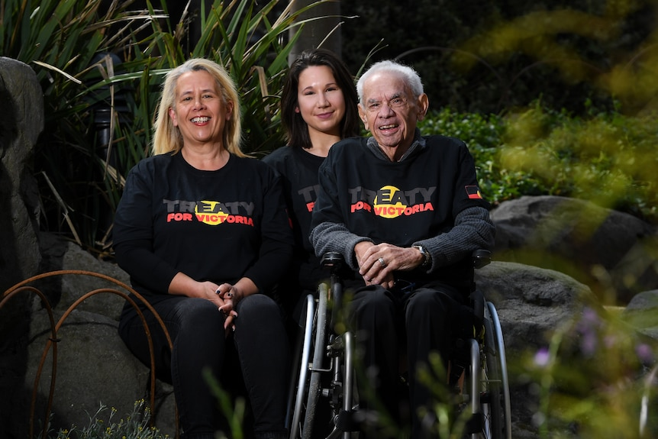
Uncle Kevin Coombs with his daughter Janine and grand-daughter Kyeema in 2019.
(AAP Image: James Ross)
Coombs was among 12 Australians who competed at the inaugural Paralympics. He also went to the 1968, '72, '80 and '84 Games.
He was captain of the Australian team at his last Paralympics, and he carried the torch at the opening ceremony for the 2000 Sydney edition.
The Uncle Kevin Coombs Medal is awarded at the end of each Paralympics year to the Australian competitor who best personifies his spirit and determination.
He was awarded the medal of the Order of Australia in 1983, and last year Coombs was the first Paralympian in the world to be officially honoured with the initials PLY after his name.
Freeman won six gold medals in athletics at the 1972 and '76 Paralympics.

