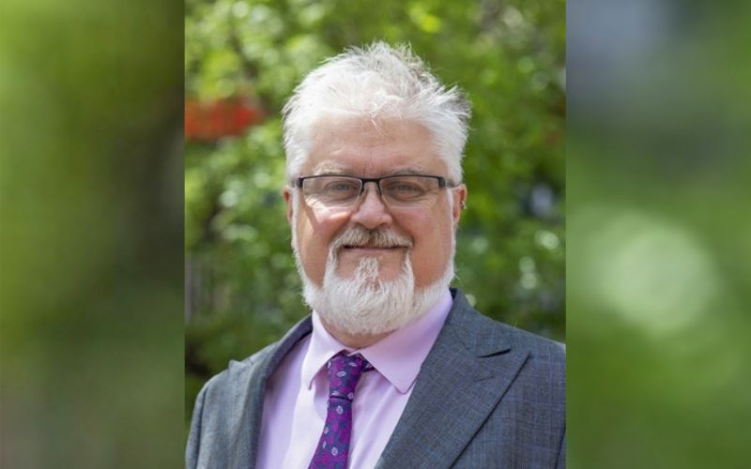

Professor Ian Anderson, a Palawa man and Deputy Vice-Chancellor (Academic) at the University of Tasmania is the new Chair of the Atlantic Fellows for Social Equity Advisory Board.

Professor Ian Anderson has been appointed as the new Chair of the Atlantic Fellows for Social Equity (AFSE) Advisory Board, based at the University of Melbourne.

Professor Anderson, a Palawa man and Deputy Vice-Chancellor (Academic) at the University of Tasmania, replaces Ms Belinda Duarte, who steps down after assuming the role in 2019.

With a distinguished career in academia and leadership at University of Melbourne, Australian National University and the Department of the Prime Minister and Cabinet, Professor Anderson has a longstanding passion for Indigenous issues and rights. His expertise has had major influence in Indigenous health policy at Australia’s highest level of government.

“This has been a year for me for coming home,” Professor Anderson said. “Coming home to the place I grew up and coming home to country. Joining the AFSE Board is a professional coming home to the University of Melbourne.

“There are many things that this program might have become but the centrality of home and belonging is fundamentally key, also too, is the understanding of what connects us all to place, to how we belong.”
Professor James McCluskey, Deputy Vice Chancellor (Research) at the University of Melbourne, congratulated Professor Anderson on his appointment.

“We are delighted to announce Professor Ian Anderson as the next Chair of the AFSE Advisory Board and are thrilled to have his input into this exceptional and unique program,’’ Professor McCluskey said.

“Ian has worked at the University of Melbourne as a Professor at the Melbourne School of Population and Global Health and has had influence over many significant programs, not the least of which was the establishment of Atlantic Fellows for Social Equity. This is a coming home in many respects, and we want to acknowledge the incredibly important role Ian has played in the foundation of this program.”

The Atlantic Fellows for Social Equity (AFSE) is an inter-cultural life-changing fellowship for Indigenous social equity in Australia, Aotearoa New Zealand and the Pacific.

AFSE was established at the University of Melbourne in 2016 with funding from the Atlantic Philanthropies, a foundation established by philanthropist Chuck Feeney. It is one of seven global, interconnected Atlantic Fellows programs worldwide.

As part of the AFSE program, fellows from Australia and Aotearoa New Zealand complete a foundation year where they develop a social change project and complete a postgraduate qualification. Upon completion, Fellows graduate into the lifelong global Atlantic Fellows community. Over the course of 20 years, the program will drive Indigenous social equity by maximising the impact of hundreds of social change makers and connecting them with thousands of peers around the world.
Professor McCluskey also paid tribute to Ms Duarte’s contribution to the program.

"Belinda has demonstrated such a steady hand all throughout the challenges we have faced, in our start-up phase. She has brought great cultural integrity to the work we are trying to do, grounded not solely as an academic exercise, but in an exercise around leadership and community and what it means to be a citizen of this country."
Applications for the 2024 cohort open in June.

