“A collective effort”: walking with mob in philanthropy

With a lifelong focus on community, culture and inclusivity, Jody Barney is leading the way in more areas than one. She is this week’s Changemaker.
- SHARE

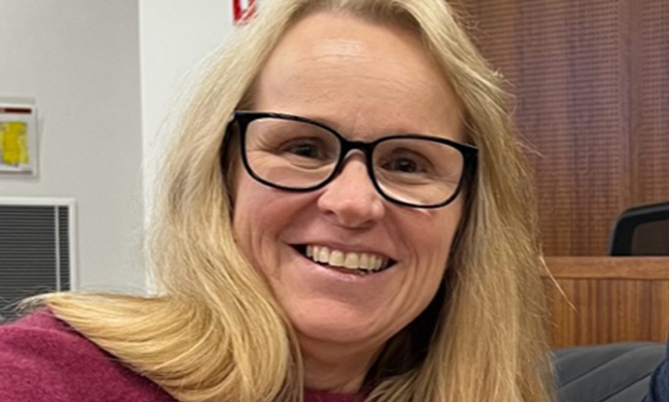

Danielle Kutchel | 10 February 2023 at 1:16 pm

Jody Barney, executive officer of Koondee Woonga-gat Toor-rong (KWT), sits at the intersection of many communities.
As a proud Deaf, First Nations woman, she blazed a trail for those who will follow in her footsteps, and now works to develop connections with community that will help mob to flourish.
Barney credits her experience across various different industries for equipping her with the cross-sectional skills she needs in her role at KWT. Studying hospitality during the 1980s, she said, “set me up to look at problem solving and having pride in my work to provide for customers the best of service”.
Her passion has always been working to help mob. Since the age of 15, she has worked with individuals who are Deaf or Hard of Hearing and using Aboriginal Sign Language. She re-studied and began working in community development to create spaces for mob with disabilities to take part in activities and programs.
From there, Barney continued studying and completed a bachelor degree in business management, along with “many other important diplomas”. She keeps her skills sharp so she can continue working in “very challenging and changing environments”, and has just completed an AICD company directors course.
“I will be using these skills to assist in the growth and development of Koondee Woonga-gat Toor-rong (KWT) and work with the board to strengthen the presence of KWT in the community and the philanthropy space,” she said.
“I support a holistic way of working with communities and services.”

How did you get the role at KWT and what does a typical day look like for you?
Firstly, I was an inaugural board member and over the years I had the privilege of working with some amazing people on the board. The concept of a First Nations-led philanthropy was too intriguing to ignore. I became the chair in late 2019 and worked with the board and our allies to provide much support and relief during very trying times and COVID-19. We at KWT developed and strengthen our presence in the philanthropy space and working with our allies to ensure the growth of KWT continued during some very stressful and uncertain times. I stepped into the EO role last August to support the growth of KWT and to get back out to community and see the amazing people and work that is being done from a culturally framed position.
A typical day for me tends to consist of normal office responsibilities, however, I have the opportunities to catch up with community and yarn about their ideas and hopes. I see people sharing stories, wanting to reconnect and develop their communities by healing and participation in activities. I work with the chair and board of KWT to ensure that the strategies of KWT are implemented. But I spend a fair amount of time on various countries sharing and working with people. It’s a very different role to what I am often doing in the advocacy space — this is now giving to community where and when the need arises and supporting people to apply for grants that can see change and hope in their respective communities.

KWT occupies a unique place in philanthropy. What are you most proud of in your role leading the organisation?
I am deeply proud of the humbled beginnings of KWT and the work we are doing to create pathways for First Nations mob across Victoria to enter into the philanthropic space. Our cultural approach of de-colonising wealth is one that takes many conversations and many yarns with both our allies, funders, Elders, and communities. I am not alone in the “leading” of KWT, it’s a collective effort in providing community applicants agency to apply in a culturally safe and informed way. In my current role as EO, it’s the yarns catching up with past applicants and seeing how their projects, activities and events have been successful. It’s the ability to work with community who are dedicated to give back to their communities, to address unmet needs and enhance other abilities to be seen, heard and to participate.

See more: Relationships, trust and community: the journey of a First Nations-led funder

Our funding rounds have seen much change in communities from establishing activities that give space to people who are often isolated or othered. Their participation has increased the social impact of well-being and participation. All activities have given us a sense of the increased social change and well-being that is culturally embedded and led by people for people on country.
Working with funders and allies is another achievement. As we are still navigating our ways amongst the others in the sector the openness and honesty of establishing those necessary relationship only increases. KWT has a truly embedded view of allyship and that we must not work in isolation but work collectively and collaboratively to create long lasting change.

What is left on your to-do list, what goals would you like to achieve in your role and your life more widely?
My to-do list is busy and often extensive. However, working with the board to ensure they align with the strategic plan of KWT is vital. It certainly reigns me in from time to time. I get excited with opportunities and offers to participate in discussions that are often without a First Nations voice. We are very lucky to have a robust and culturally informed charter that gives me space to continue the yarns and participate with others who are doing amazing work with their grants from KWT.
Building more pathways with donors to invest in our space and generate opportunities that are often sidelined by conventional granting processes. After completing some study recently, it has given me food for thought of how to utilise our cultural sense of giving and caring to develop a more robust and streamlined approach of building KWT’s presence and participation in the philanthropy sector.

You’re the first Deaf Aboriginal woman to lead a philanthropy organisation, do you hope to inspire others and lead the way?
I have been lucky to have a lot of firsts as a Deaf Aboriginal woman, and now having the ability to work with the current KWT board which continuously strives for diversity and inclusion speaks volumes. I do take the role seriously because of the work that is being done and the impact it has in our communities. I do try to take myself out of the equations.
However, to affect change we need to challenge and strive for our own point of difference. Often there are others who feel such a role shouldn’t be given to people with disabilities. This mindset has to change. If my current role is to generate those conversation amongst others in the philanthropy sector, then it’s all good. However, I do hope that others will be inspired to participate, create, generation and delegate roles across the community to design, implement, review, and evaluate their roles in the philanthropy sector so we can showcase the amazing talent of First Nations people.

As a First Nations woman with a disability, have you faced extra challenges through your career?
Unfortunately, yes, I have, and it does continue on a regular basis. I have been working since the age of 15 and many examples of discrimination, audism, racism, and homophobia happen in various arenas. I am constantly educating, deflecting and leading change by challenging those views but also do it from a place of shared learning. However, it does happen and can get you down if you don’t do self-reflection and seek out supports when needed. It’s when it creeps up on you after speaking and working with people who you thought would have your back it does get to be more hurtful and many leave the sector due to these behaviours. Why subject yourself to behaviours and ignorance of others? You need to work in a space that allows you to flourish, not be extinguished.

What advice do you have for others following in your footsteps to make it through those barriers? How can we actually remove those barriers for generations to come?
My only advice to others is to be true to yourself, we can only identify and change our own behaviours. But to find the like-minded/like-hearted people to work with that will bring you joy to thrive in the work you wish to do. We will always be challenged when adversity is both conscious and unconscious. We can only give ourselves time to reflect on our response to those barriers. A future without barriers is a universal inclusive world. One I don’t think I will see in my lifetime. However, I am mindful of the changes that have happened since my parents’ journey. So, I am hoping that our views of thinking seven generations ahead will give us a world that is sustainable and without barriers.

KWT has a focus on community-building and the development of trust. How can other philanthropy organisations learn from you?
KWT and the work that we do in the community can definitely be done by other philanthropic organisations. The development of trusted relations and community building can be done within the philanthropic sector. Our work with the Paul Ramsay Foundation, Australia Communities Foundation and Fellowship of Indigenous Leadership is a great model of allyship and trust. Our works over the few years has given KWT the ability to try and test the waters as well as building on our relationships with others that share our ethos. This building of leadership and trust must be done with the lens of First Nations of knowing, being and doing. We at KWT are always up for a yarn and talk with others within the sectors to nurture a more culturally inclusive sector.

What challenges are facing KWT and the philanthropy sector more generally, and how do you plan to navigate through those?
A global pandemic has certainly kept us all on our toes, and challenged the way we all engaged and create space in understanding the deep needs of communities. We also have global crises with the environment and there are many conversations that are required to ensure we work with an environmental and cultural lens from funding cultural walks to cultural gatherings. We are also concerned about digital literacy and… [the] cyber security of our mob who have digital literacy needs. The landscape of First Nations voices with the referendum on Voice to Parliament, or Treaty, Land Rights, and cultural appropriation are issues faced by the community who seek grants to focus on those topics. We also have large challenges due to ongoing COVID and extreme weather events such as the recent floods in Victoria.
We at KWT continuously have our “ear” to the ground and listen to our communities about what is currently going on, not only what is needed but what is on offer. This “sharing and caring” is an important factor of doing business as we do our own style of philanthropy that follows those processes.

What motivates you each day?
Mob, they motivate me every day, whether I am in community, on Country, in a boardroom, or meetings on Zoom. My motivation is to speak with clarity, understanding and honesty. I am motivated by the deadly work done by mob and how they generate change. The work I have seen being funded and the outcomes increases my motivation to get back out there and yarn with more and more people. I am also motivated by the relationships we foster in creating the work we do at KWT. I am deeply motivated by my family in trusting me to be away and to work in community and showcasing the awesome work that is being done across communities. Motivation is so necessary… the day I am no longer motivated is the day I hand over the reins to someone else.

Danielle Kutchel | @ProBonoNews
Danielle is a journalist specialising in disability and CALD issues, and social justice reporting. Reach her on danielle@probonoaustralia.com.au or on Twitter @D_Kutchel.

